1. **Develop a website with a GridView which displays the details of ‘Staff’ table. The Name and Age fields should be in a single cell under the column heading Staff details. This Staff details column should provide Name wise sorting. The rows that contain the age more than 35 should be highlighted. Add at least five rows to the Staff table which has the fields as follows: Name, Age, Designation, and Salary**

**Staff Table Schema and Data:**

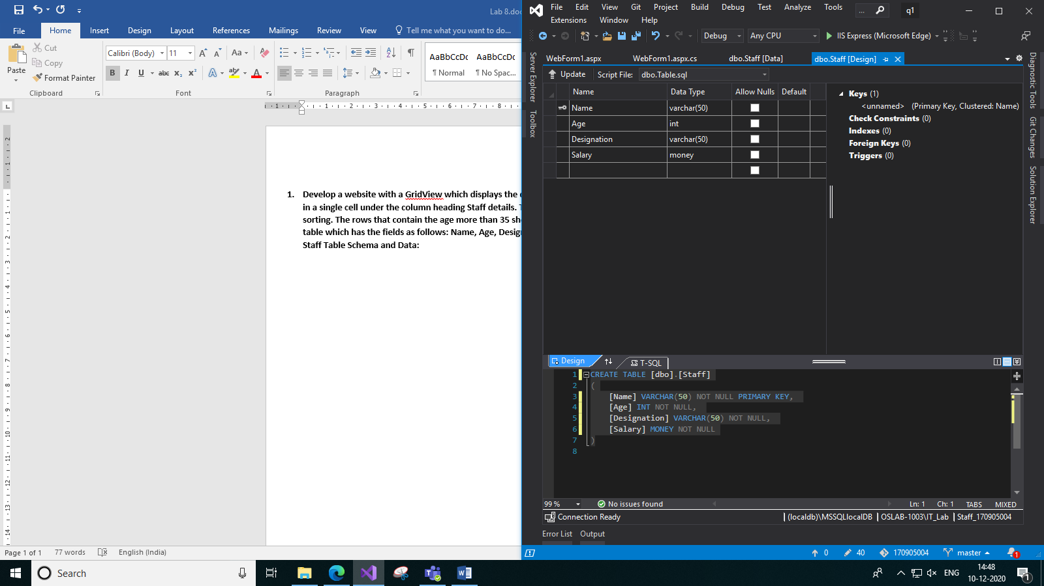 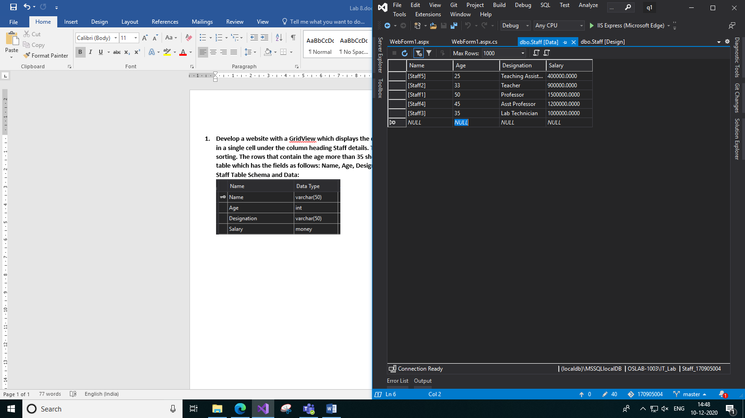

**Code:**

**WebForm1.aspx:**

<%@ Page Language="C#" AutoEventWireup="true" CodeBehind="WebForm1.aspx.cs" Inherits="q1.WebForm1" %>

<!DOCTYPE html>

<html xmlns="http://www.w3.org/1999/xhtml">

<head runat="server">

<title>Staff</title>

</head>

<body style="background-color: rgba(204, 229, 251, 0.65); text-align: center">

<form id="form1" runat="server">

<div>

<h2 style="font-family: Bahnschrift">Details of Staff</h2>

<asp:SqlDataSource ID="SqlDataSource1" runat="server" ConnectionString="<%$ ConnectionStrings:Staff_170905004ConnectionString %>" SelectCommand="SELECT * FROM [Staff]"></asp:SqlDataSource>

<br />

<asp:GridView ID="GridView1" runat="server" AutoGenerateColumns="False" DataKeyNames="Name" DataSourceID="SqlDataSource1" OnRowDataBound="RowDataBound" CellPadding="4" ForeColor="#333333" GridLines="None" HorizontalAlign="Center" style="margin: auto" HeaderStyle-Height="50px">

<AlternatingRowStyle BackColor="White" ForeColor="#284775" />

<Columns>

<asp:TemplateField HeaderText="Staff Details" SortExpression="Name">

<ItemTemplate>

<b>Name: </b>

<%#Eval("Name") %><br />

<b>Age: </b>

<%#Eval("Age") %>

</ItemTemplate>

</asp:TemplateField>

<asp:BoundField DataField="Designation" HeaderText="Designation" SortExpression="Designation" />

<asp:BoundField DataField="Salary" HeaderText="Salary" SortExpression="Salary" />

</Columns>

<EditRowStyle BackColor="#999999" />

<FooterStyle BackColor="#5D7B9D" Font-Bold="True" ForeColor="White" />

<HeaderStyle BackColor="#5D7B9D" Font-Bold="True" ForeColor="White" />

<PagerStyle BackColor="#284775" ForeColor="White" HorizontalAlign="Center" />

<RowStyle BackColor="#F7F6F3" ForeColor="#333333" />

<SelectedRowStyle BackColor="#E2DED6" Font-Bold="True" ForeColor="#333333" />

<SortedAscendingCellStyle BackColor="#E9E7E2" />

<SortedAscendingHeaderStyle BackColor="#506C8C" />

<SortedDescendingCellStyle BackColor="#FFFDF8" />

<SortedDescendingHeaderStyle BackColor="#6F8DAE" />

</asp:GridView>

</div>

</form>

</body>

</html>

**WebForm1.aspx.cs:**

using System;

using System.Collections.Generic;

using System.Linq;

using System.Web;

using System.Web.UI;

using System.Web.UI.WebControls;

namespace q1

{

public partial class WebForm1 : System.Web.UI.Page

{

protected void Page_Load(object sender, EventArgs e)

{

}

protected void RowDataBound(object sender, GridViewRowEventArgs e)

{

if(e.Row.RowType == DataControlRowType.DataRow)

{

int age = (int)DataBinder.Eval(e.Row.DataItem, "Age");

if(age > 35)

{

e.Row.BackColor = System.Drawing.Color.LightGray ;

e.Row.ForeColor = System.Drawing.Color.DarkSlateGray;

e.Row.Font.Bold = true;

}

}

}

}

}

**Output:**

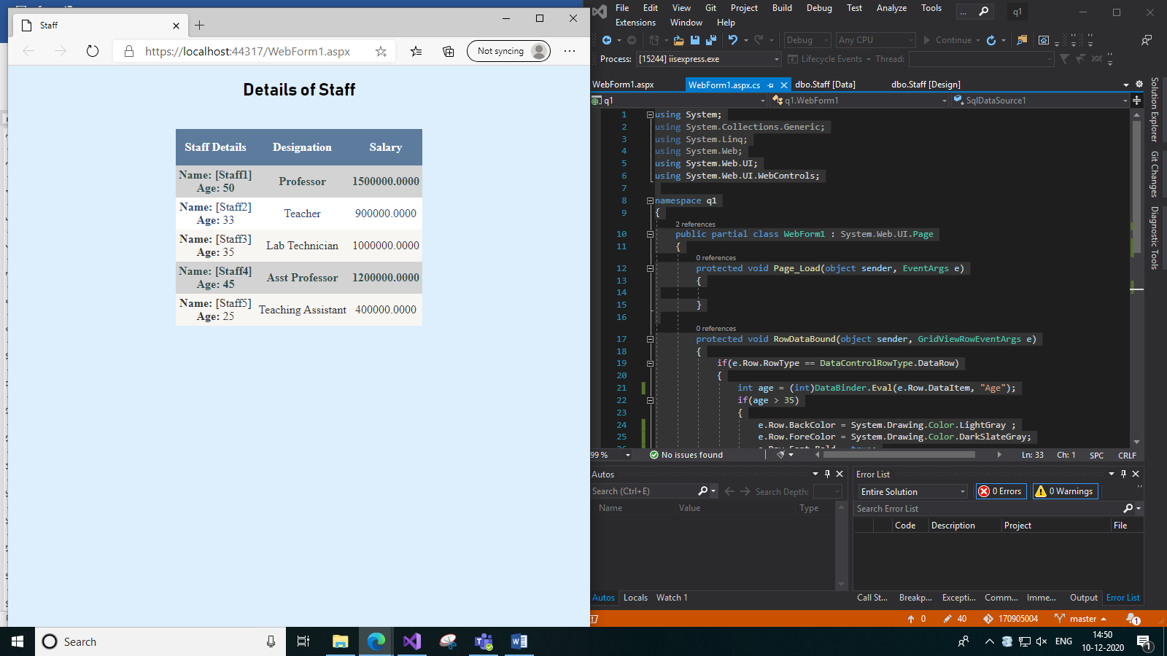

1. **Develop a web page that retrieves author details from the table ‘Authors’ and displays it in a GridView. The maximum records in each page can be 3. Change background color to ‘green’ and text color to ‘red’ with bold font for the header. Use data source control to fetch data. Give provisions to edit the values of FirstName and CopiesSold.**

**Authors table schema and data:**

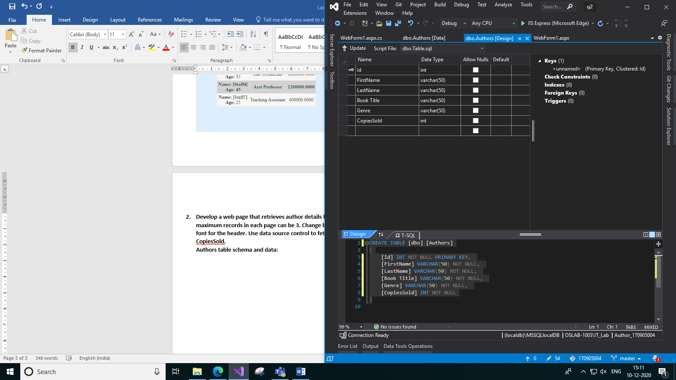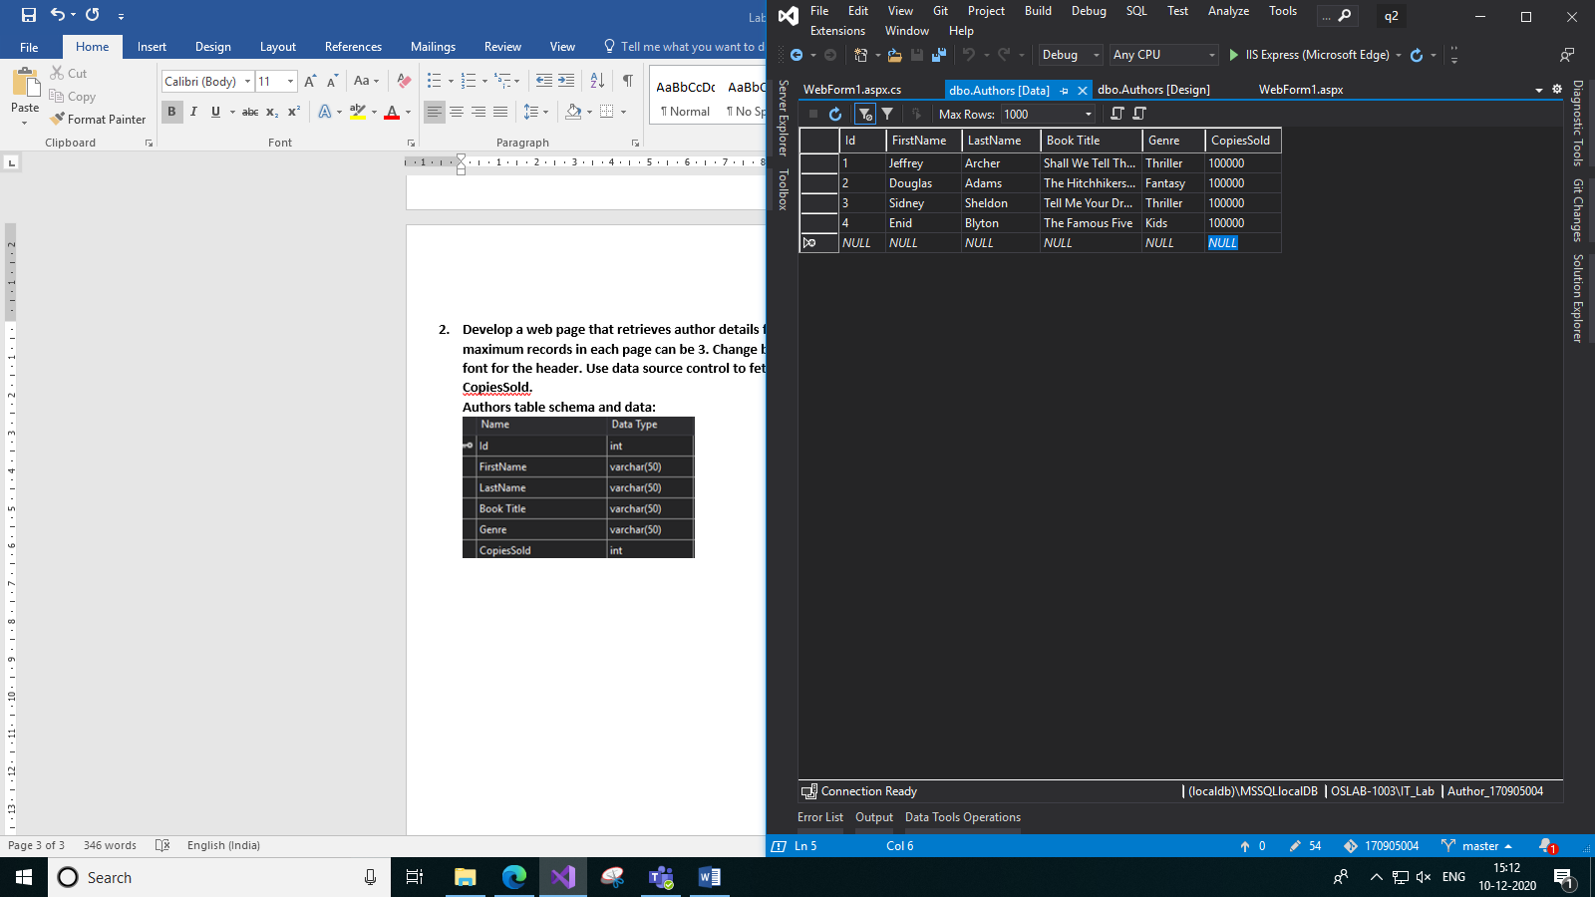

**Code:**

**WebForm1.aspx:**

<%@ Page Language="C#" AutoEventWireup="true" CodeBehind="WebForm1.aspx.cs" Inherits="q2.WebForm1" %>

<!DOCTYPE html>

<html xmlns="http://www.w3.org/1999/xhtml">

<head runat="server">

<title>Authors</title>

</head>

<body>

<form id="form1" runat="server">

<div>

<h2 style="font-family: Bahnschrift">Authors</h2>

<asp:SqlDataSource ID="SqlDataSource1" runat="server" ConnectionString="<%$ ConnectionStrings:Author_170905004ConnectionString %>" SelectCommand="SELECT * FROM [Authors]" UpdateCommand="UPDATE Authors SET FirstName=@FirstName, CopiesSold=@CopiesSold WHERE Id=@Id"></asp:SqlDataSource>

<br />

<asp:GridView ID="GridView1" runat="server" AutoGenerateColumns="False" DataKeyNames="Id" DataSourceID="SqlDataSource1" AllowPaging="True" PageSize="3" HorizontalAlign="Center">

<HeaderStyle BackColor="Green" ForeColor="Red" Font-Bold="true" />

<Columns>

<asp:CommandField ShowEditButton="True" ItemStyle-HorizontalAlign="Center" />

<asp:BoundField DataField="Id" HeaderText="Id" ReadOnly="True" SortExpression="Id" ItemStyle-HorizontalAlign="Center"/>

<asp:TemplateField HeaderText="Name" ItemStyle-HorizontalAlign="Center">

<ItemTemplate>

<b>First Name: </b>

<%#Eval("FirstName") %>

<br />

<b>Last Name: </b>

<%#Eval("LastName") %>

</ItemTemplate>

<EditItemTemplate>

<b>First Name: </b>

<asp:TextBox Text='<%#Bind("FirstName")%>' runat="server" ID="txtFirstName"></asp:TextBox>

<br />

<b>Last Name: </b>

<%#Eval("LastName") %>

</EditItemTemplate>

</asp:TemplateField>

<asp:BoundField DataField="Book Title" HeaderText="Book Title" SortExpression="Book Title" ReadOnly="true" ItemStyle-HorizontalAlign="Center" />

<asp:BoundField DataField="CopiesSold" HeaderText="CopiesSold" SortExpression="CopiesSold" ItemStyle-HorizontalAlign="Center" />

</Columns>

</asp:GridView>

</div>

</form>

</body>

</html>

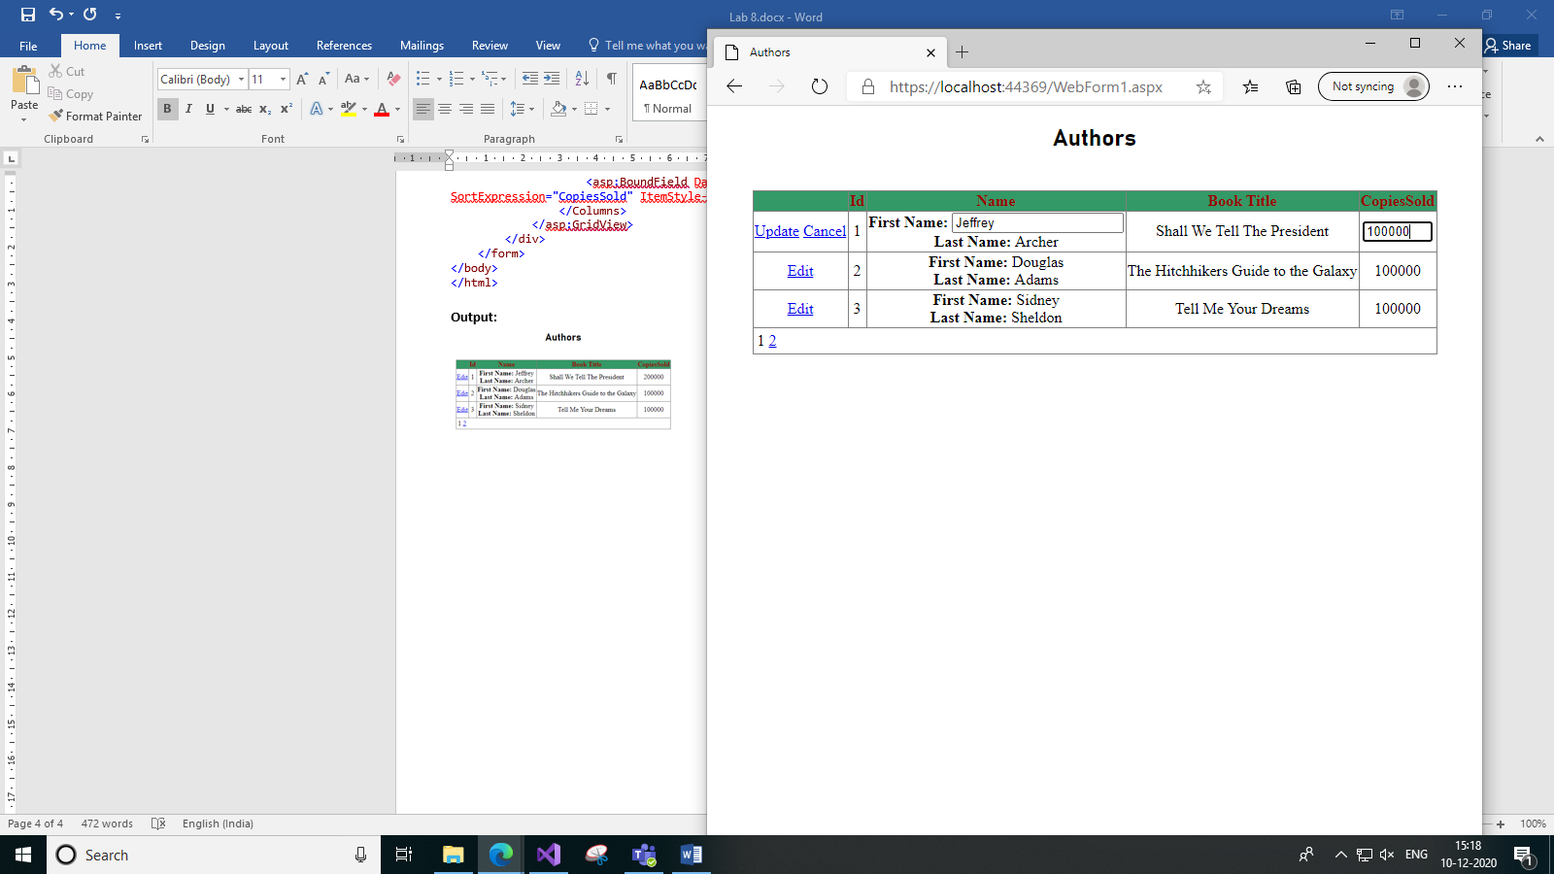**Output:**

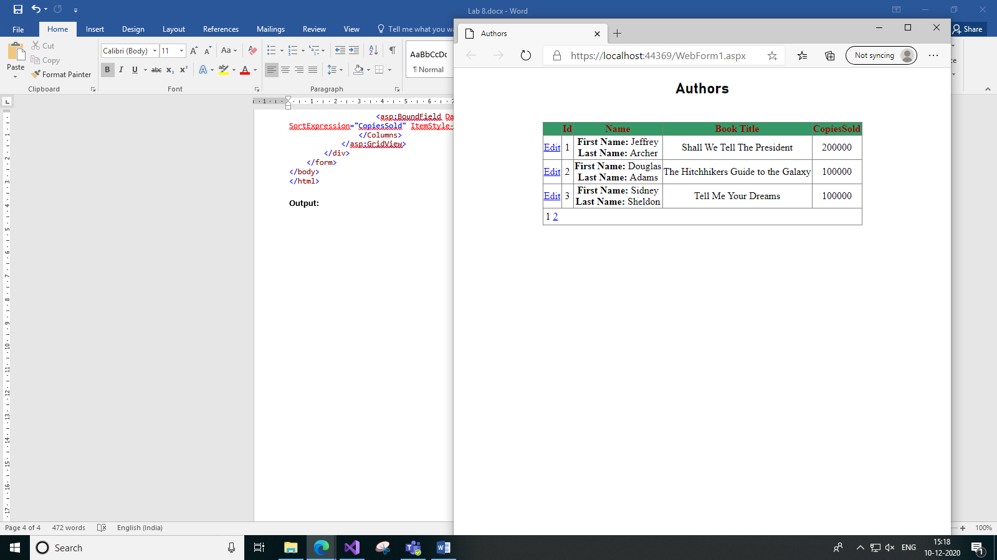

1. *Before Editing b) Editing*

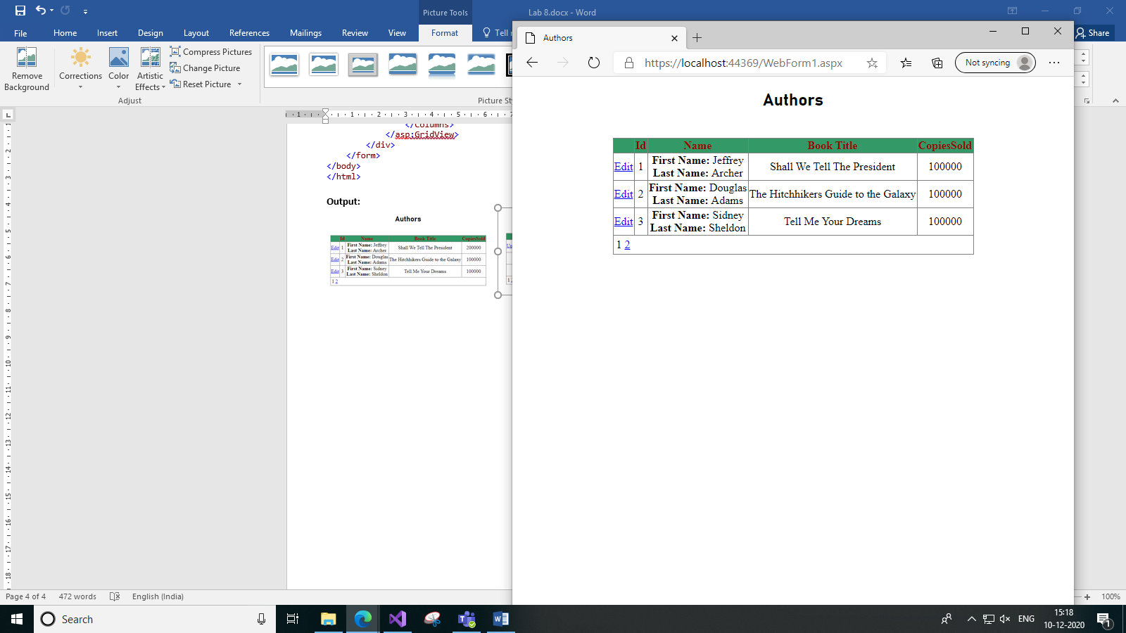

1. *After Editing*
2. **Create an xml file using XDocument class. The file should contain the following elements. I20Hyundai700000 I20Hyundai 700000**

**Code:**

**WebForm1.aspx:**

<%@ Page Language="C#" AutoEventWireup="true" CodeBehind="WebForm1.aspx.cs" Inherits="q3.WebForm1" %>

<!DOCTYPE html>

<html xmlns="http://www.w3.org/1999/xhtml">

<head runat="server">

<title>XML Creation</title>

</head>

<body>

<form id="form1" runat="server">

<div>

<h3>Creating an XML files on Cars.</h3>

<br />

File Name: Cars.xml

</div>

</form>

</body>

</html>

**WebForm1.aspx.cs:**

using System;

using System.Collections.Generic;

using System.Linq;

using System.Web;

using System.Web.UI;

using System.Web.UI.WebControls;

using System.Xml.Linq;

using System.IO;

namespace q3

{

public partial class WebForm1 : System.Web.UI.Page

{

protected void Page_Load(object sender, EventArgs e)

{

string file = Path.Combine(Request.PhysicalApplicationPath, @"App_Data\Cars.xml");

XDocument doc = new XDocument(

new XElement("Cars",

new XElement("Detail",

new XElement("Name", "I20"),

new XElement("Make", "Hyundai"),

new XElement("Price", "700000")

),

new XElement("Detail",

new XElement("Name", "I20"),

new XElement("Make", "Hyundai"),

new XElement("Price", "700000")

)

)

);

doc.Save(file);

}

}

}

**Output:**

**Cars.xml file:**

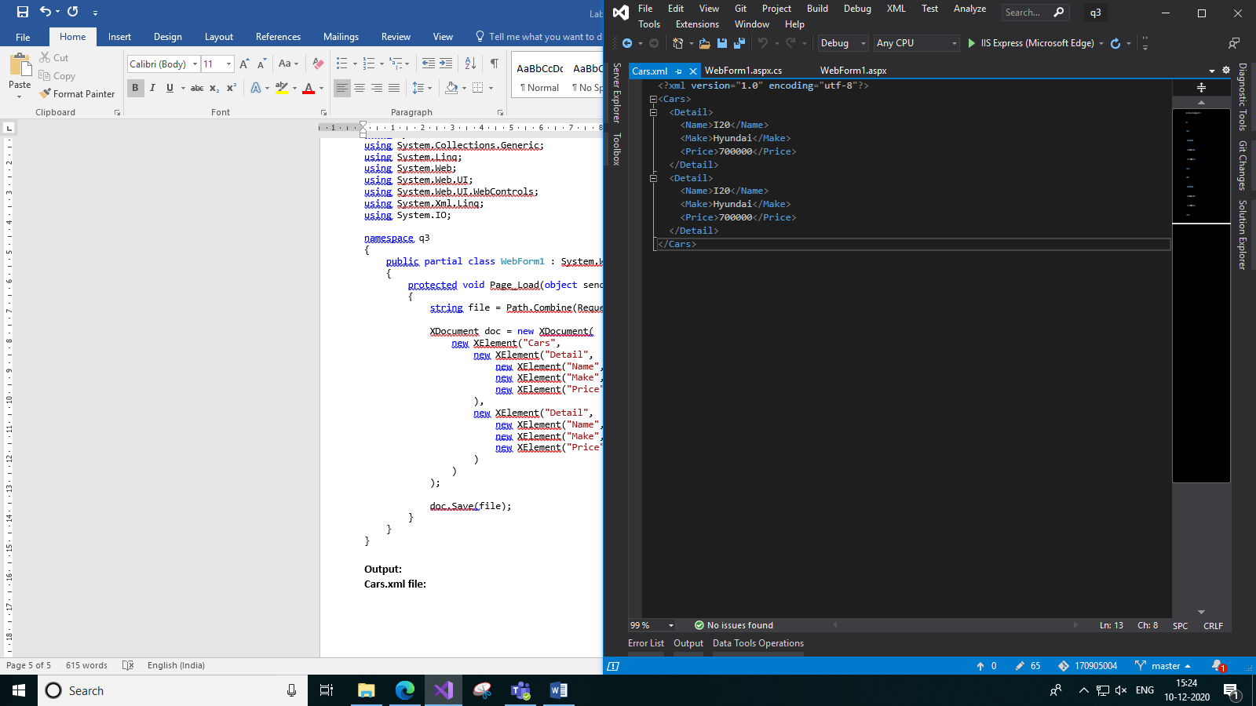

**Additional1. Develop a website to display the contents of ‘Product’ table (id, name, price, quantity) using GridView. The user should be allowed to edit the name and quantity fields only. Use appropriate validation controls to ensure that the name field is not blank and the quantity is between 1 and 20. Enable sorting of GridView based on ‘id’ and ‘name’ columns. Sample GridView is shown below:**

**Product table schema and data:**

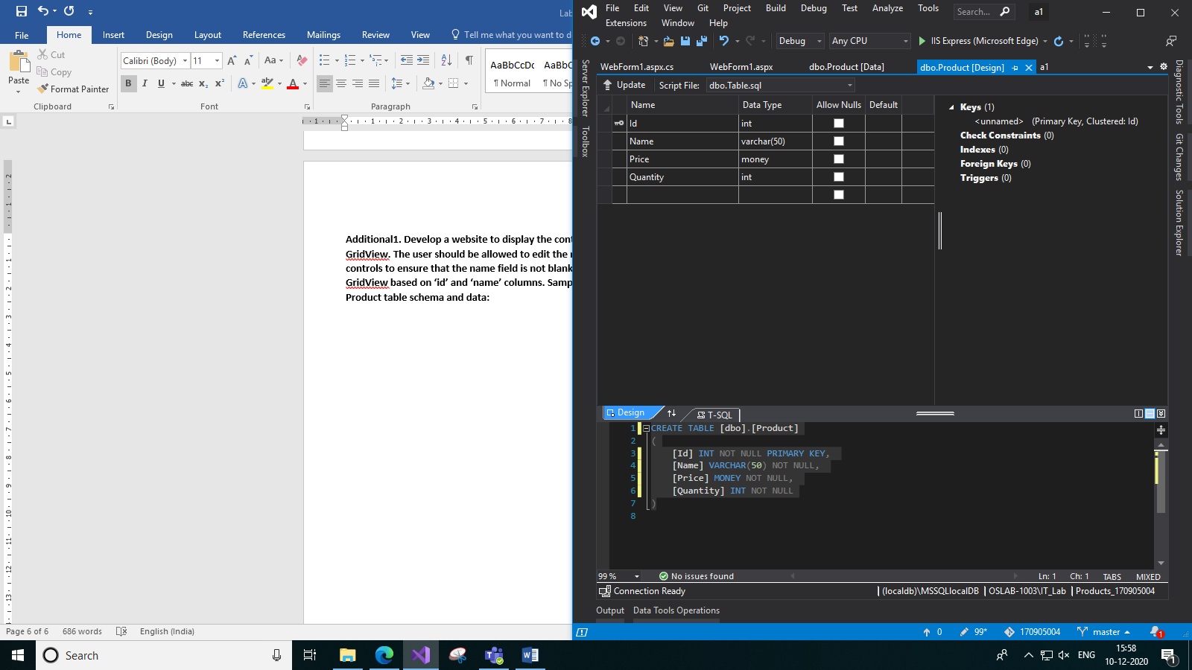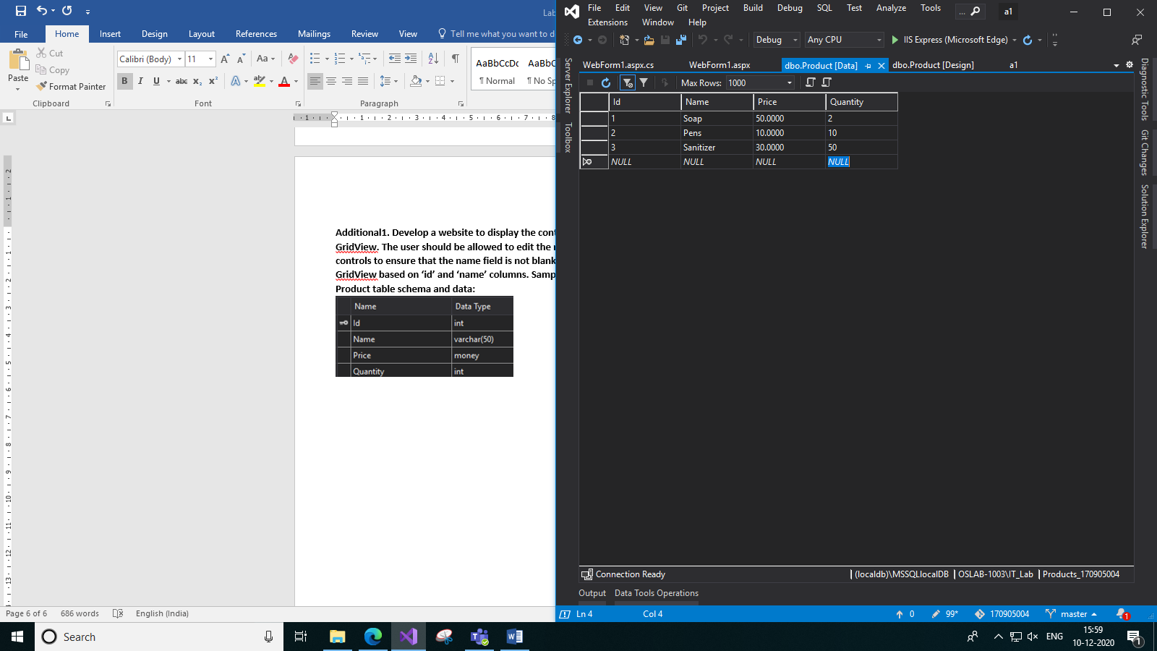

**Code:**

**WebForm1.aspx:**

<%@ Page Language="C#" AutoEventWireup="true" CodeBehind="WebForm1.aspx.cs" Inherits="a1.WebForm1" %>

<!DOCTYPE html>

<html xmlns="http://www.w3.org/1999/xhtml">

<head runat="server">

<title>Products</title>

</head>

<body>

<form id="form1" runat="server">

<div>

<h2 style="font-family: Bahnschrift; text-align: center">Products</h2>

<br />

<asp:SqlDataSource ID="SqlDataSource1" runat="server" ConnectionString="<%$ ConnectionStrings:Products_170905004ConnectionString %>" SelectCommand="SELECT * FROM [Product]" UpdateCommand="UPDATE Product SET Name=@Name, Quantity=@Quantity WHERE Id=@Id"></asp:SqlDataSource>

<br />

<asp:GridView ID="GridView1" runat="server" AutoGenerateColumns="False" DataKeyNames="Id" DataSourceID="SqlDataSource1" AllowSorting="True" HorizontalAlign="Center">

<HeaderStyle ForeColor="Black" Font-Bold="true" Font-Size="Medium"/>

<Columns>

<asp:BoundField DataField="Id" HeaderText="Id" ReadOnly="True" SortExpression="Id" />

<asp:TemplateField HeaderText="Name" SortExpression="Name">

<ItemTemplate>

<%#Eval("Name") %>

</ItemTemplate>

<EditItemTemplate>

<asp:TextBox ID="TextBox2" runat="server" Text='<%#Bind("Name") %>'></asp:TextBox>

<asp:RequiredFieldValidator ID="RequiredFieldValidator1" runat="server" ErrorMessage="Name Required" ControlToValidate="TextBox2"></asp:RequiredFieldValidator>

</EditItemTemplate>

</asp:TemplateField>

<asp:TemplateField HeaderText="Details">

<ItemTemplate>

Price:

<%#Eval("Price") %><br />

Quantity:

<%#Eval("Quantity") %>

<br />

</ItemTemplate>

<EditItemTemplate>

Price:

<%#Eval("Price") %><br />

Quantity:

<asp:TextBox ID="TextBox1" runat="server" Text='<%#Bind("Quantity") %>'></asp:TextBox>

<asp:RangeValidator ID="RangeValidator1" runat="server" ErrorMessage="Quantity has to be in the range of 1-20" ControlToValidate="TextBox1" MinimumValue="01" MaximumValue="20"></asp:RangeValidator>

</EditItemTemplate>

</asp:TemplateField>

<asp:CommandField ShowEditButton="true" />

</Columns>

</asp:GridView>

</div>

</form>

</body>

</html>

**Output:**

